GOOD SHEPHERD CATHOLIC PRIMARY SCHOOL

EVANGELISATION PLAN

2018-2020

EVANGELISATION

Evangelisation:
- The Evangelisation process at Good Shepherd Catholic Primary School is based on Living witness in words and actions that reflects Christlike presence and love of others.
- It is about proclaiming the Good News in the same ways that Jesus did through striving to be a good school and teaching children to integrate Faith, Life and Culture, nurturing and releasing the Divine Imagination in all children.

School Vision
- With the Good Shepherd as our guide, working together to nurture and develop the whole child.

Signs of the times
There are many unique factors that affect the current situation at Good Shepherd Catholic Primary School which can be seen as our ‘Signs of the Times’. These include:

- A high portion of Non-Catholic students and families
- A limited practice of the Catholic faith outside the school environment by students and their families who are Catholic
- The strong and supportive partnership between the school parish, Good Shepherd Parish Kelmscott and the school.
- The school and the parish are not on the same site and this presents many challenges
- We have varied levels of faith and spirituality amongst our staff members who continually need to develop their ability to share their faith and reflect Jesus in word and action.
- The Liturgical life of the school is rich, child-centred and varied.
- The visual signs of our catholicity could be more prominent throughout the school.
- Our school community is made up of devout practicing catholic families, non-practicing catholic families and families from other religions.
- We have a very supportive community who assist in many areas of the school. Our Board and Parent Group are very dedicated.
- Sacramental programmes and commitment Masses are well attended.

Challenges
- Ways to raise awareness to recognise the influence of God in the school and in society.
- Witnessing Christian simplicity and the Gospel spirit of poverty in an affluent and materialistic society.
- Reflecting a spirit of Christian service.
- Involving all with Gospel concerns through the provision of education, social justice, ecological awareness and preferential option for the poor.
- Raising awareness to recognise the influence of God in our school and in society.
- Understanding and living the religious and moral teachings of Jesus.
Witness: (Christian Witness is always ‘the first act of evangelisation.’ Witness is how people strive to live as they respond to the god who dwells within them.)
- At Good Shepherd Catholic Primary School, we are the Signs of the Times and thus we must engage the whole person – head, heart and lifestyle. Through our efforts to be Christ-like:
- We strive to treat everyone with respect and dignity;
- Build positive relationships;
- Pray together;
- Seek social justice;
- Welcome and support the spirit of family;
- Help the children to recognise the influence of God in their lives, our school and the world.
- Primary Proclamation: (Primary Proclamation calls people to accept initial personal relationships with Jesus Christ himself as their Lord and Saviour.)
It is opening the door to Jesus. It is saying ‘Yes” to Jesus. It is an ‘apprenticeship.’ It is providing opportunities so that everyone in our community will accept and develop a personal relationship with Jesus.
- Initiatory Catechesis: (It aims to help people mature from initial conversion to Jesus that results from fruitful primary proclamation, to a deeper personal relationship with Jesus.)
It is building on Primary Proclamation – like an apprenticeship. It is nurturing that ‘Yes’ to Jesus. It is about helping each person to deepen his/her knowledge and, in turn, helping him/her to be in communion and intimate relationship with Jesus.

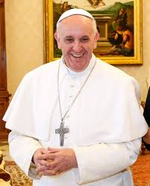

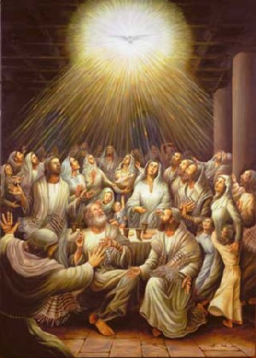
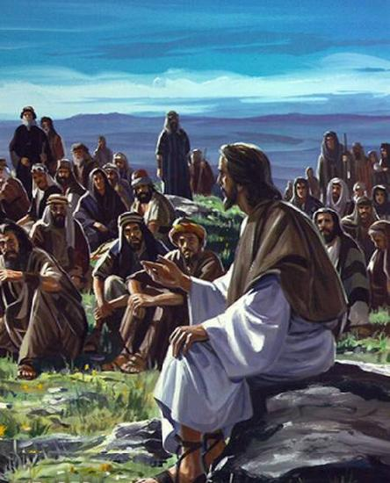

PRIMARY PROCLAMATION

Primary Proclamation calls people to accept initial
personal relationships with Jesus Christ
himself as their Lord and Saviour

SAYING ‘YES’ TO JESUS

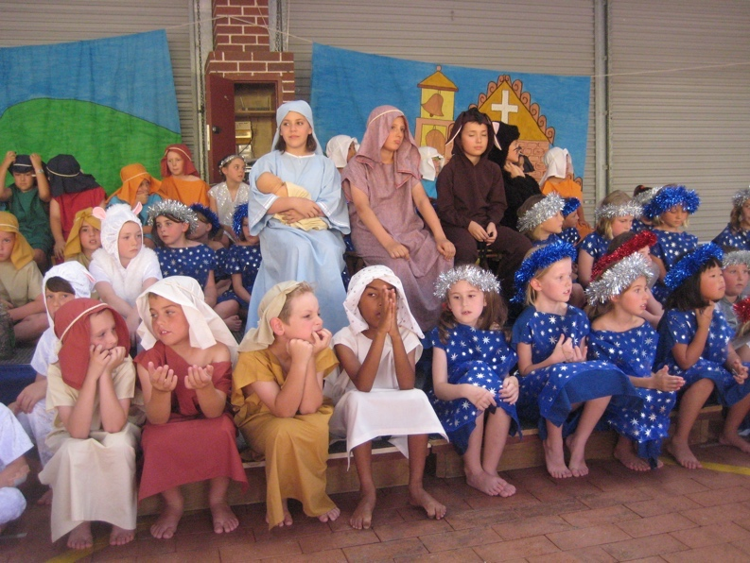

A. THE PRIMARY PROCLAMATION (1)
Sacred Focus  (Classroom prayer centre, chapel, crucifix etc | Reverence Sign  (‘Etiquette’, expressions of reverence) | Effectiveness Indicators
The church (off site)  The Sacred Space  Crucifixes in every room  Prayer tables in every class room  Class Bibles  Rosary Beads  Statues or pictures of Mary and Jesus  School Vision & motto on display in every classroom | Making the Sign of the Cross reverently/Holy Water font  Genuflecting/Sign of Peace.  Daily prayer/Praying quietly/Reflection/Meditation.  Ritual gestures - standing, kneeling, sitting, bowing  Quiet reverence in Church and in the Sacred Space.  Participation through responses in prayer, liturgy and at Mass.  Recognising the class prayer table, church and sacred space. | Observation on entering, during and leaving church  Level of participation  Level of understanding and respect  Deepening the understanding of rituals and gestures and why we do them e.g. why do we bless ourselves and what does it mean?
Staff Formation | Opportunities for Weekly Staff Prayer  Opportunities for Staff to develop their knowledge of Faith, Spirituality and Catholicism  Opportunities for Faith formation through retreat days and staff reflections. | Effectiveness Indicators  Sharing an understanding of personal faith and knowledge with other staff, parents and students.  Modelling our faith through sincere prayer, planning effective prayer sessions, liturgies and Religious education lessons.
A. THE PRIMARY PROCLAMATION (2)
Theme | When Proclaimed  (Feast, event, etc) | How  (Method) | Where  (Assembly, newsletter, etc) | Effectiveness Indicators
God made us in his own image and likeness.  God loves us | - Activities prior to Special Solemnities and Events to build understanding of their importance  - Good Shepherd Feast Day  - Harmony Day  - Kartijiin Day/Week  - Ash Wednesday  - Lent/Holy Week  - Project Compassion/Mission/Life Link  - Feast of Ascension  - Feast of Pentecost  - Feast of Trinity  - Feast of Body & Blood of Christ  - Feast of Mary MacKillop  - Feast of the Assumption  - Feast of All Saints  - Advent/Christmas  - Celebrating the Month of May as Mary’s Month | - Classroom activities to reflect the importance of Special Solemnities and Events.  - Whole School Mass & feast day celebration  - Whole School Masses on Days of Solemnity  - Class Mass (Yr4-6)  - Class prayer liturgies (kindy – Y3)  - Yrs 3-6 Reconciliation during Lent and Advent  - Re-enactment of Holy Week  - Sacrament of Confirmation  - First Holy Communion  - Sacrament of First Penance  - Christmas plays  - Staff modeling of the proclamation of the word  - School Calendar to highlight Feast Days  - Reflect on Gospels prior to whole school Masses.  - Mention Feast Days for coming week at Assembly & in the Newsletter  - Teaching and Praying the Rosary in May within the classroom or as a whole school. | - To highlight events and protocols to parents through the School Newsletter & Website  - Fliers  - Board and P&F involvement  - Church /School grounds | The protocols to understand and respect our rituals  To show reverence in church before, during and after liturgies.  Students seeking clarification & support from teacher.  Student level of participation.
Staff Formation  What do we need to achieve the above? | How When Who  Background information regarding Feast Days in order to impart to children. |  |  | Effectiveness Indicators  Students being to demonstrate events and feast days by explaining activities and participating in questions during the homily.

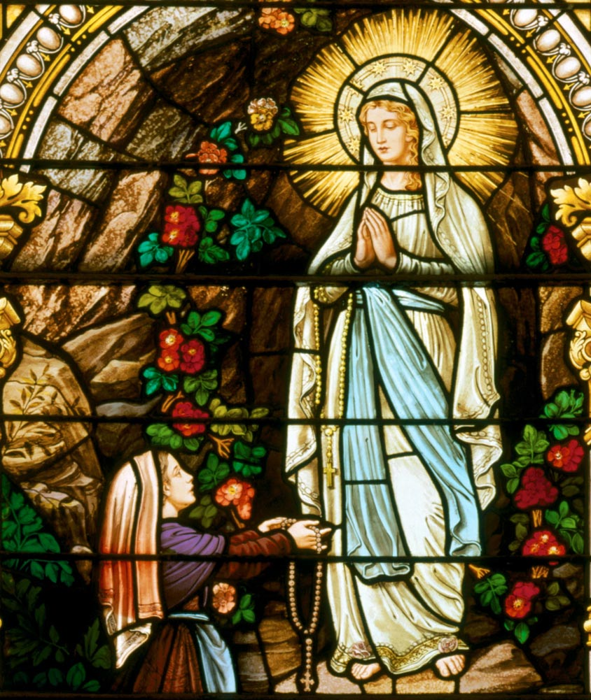
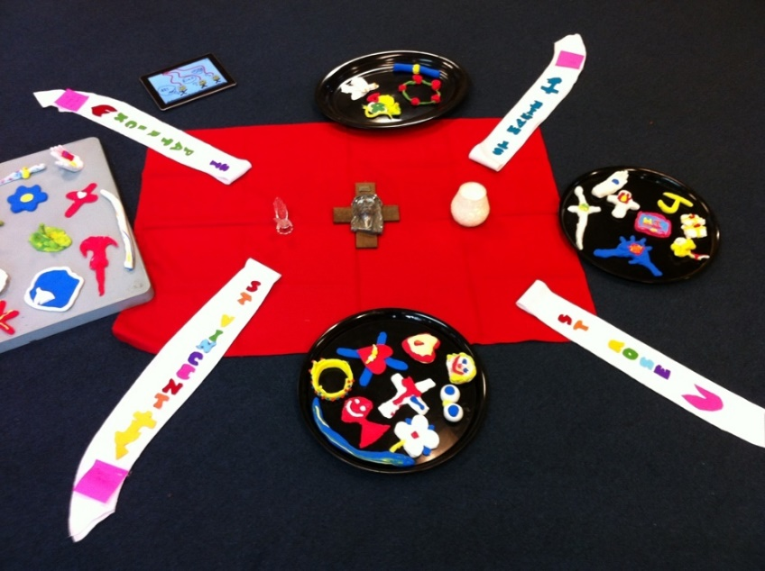
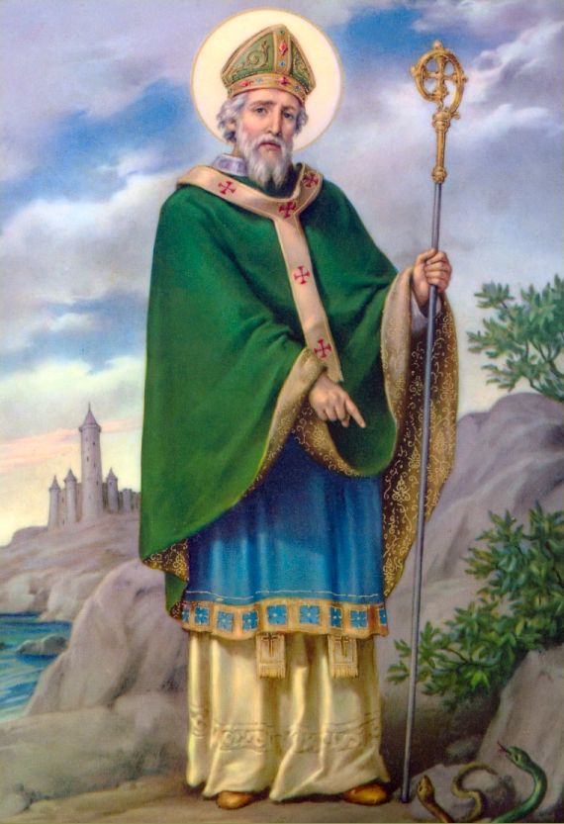

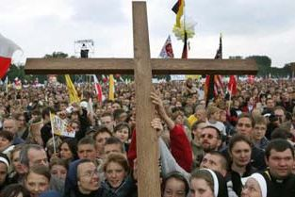
INITIATORY CATECHESIS

Initiatory Catechesis aims to help people mature from
Initial conversion to Jesus that results from fruitful primary
proclamation, to a deeper personal relationship with Jesus

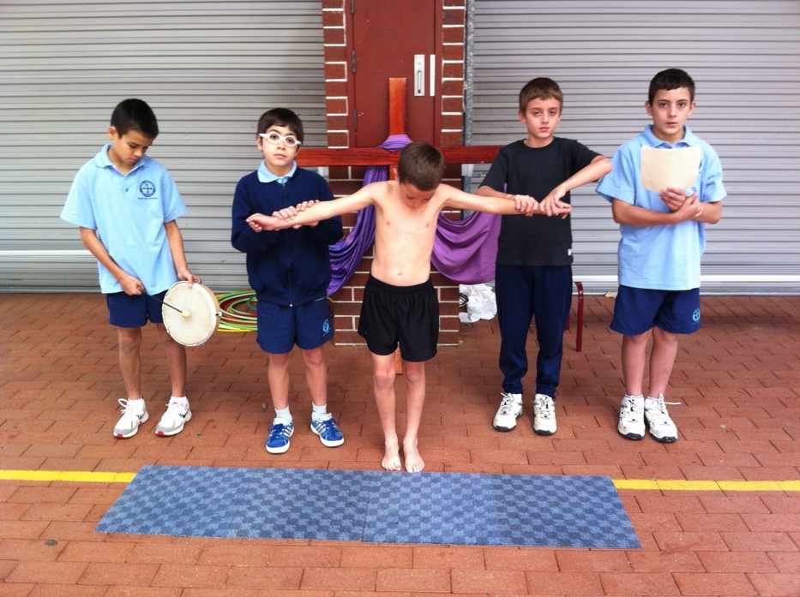
NURTURING THROUGH FAITH, LOVE AND LAUGHTER
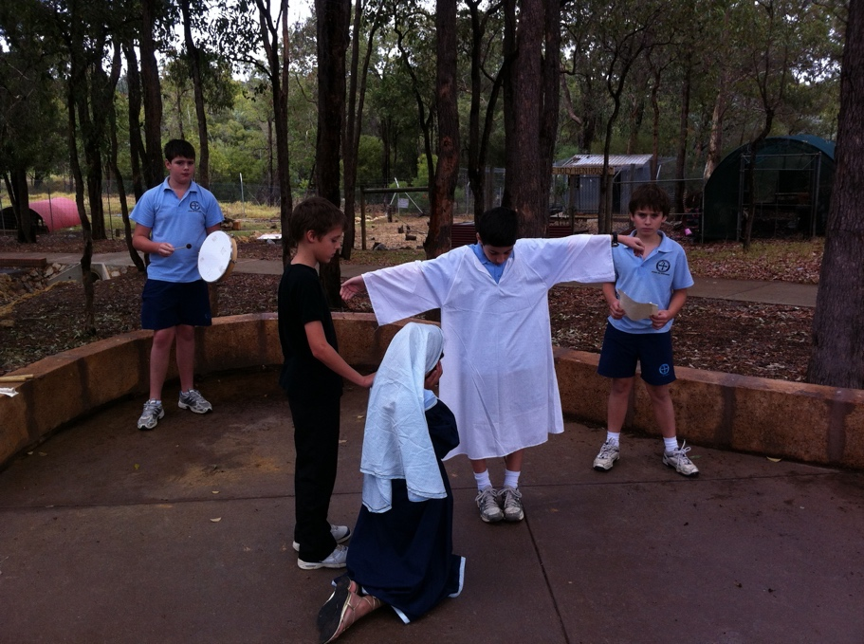

B. Believing Community - An Apprenticeship
Select EXPERIENCES from…… | Belief to be proclaimed  (Identify experience) | Feast / Event | Witness:  Way the belief is to be proclaimed  e.g. newsletter, school prayer, etc | Effectiveness Indicators
God:  The Creator  Jesus Christ:  Incarnation  The Paschal  Mystery  Resurrection of the body  The Holy Spirit:  The Spirit  in the Church:  Forgiveness of sins | We are created by God, in God’s own image and likeness.  God loves us  We reflect God when we portray His attributes  The Sacrament of first Penance  God sent his only son  Jesus died for us  Sacrament of First Eucharist was first instituted at the Last Supper  Easter  God sent the Holy Spirit at Pentecost.  We receive the Holy Spirit in Confirmation | Living the Vision:  Capturing the joy in the mystery of the created Universe  Sacrament of Reconciliation  Hospitality – Welcoming all who join in our community.  Forgiving and empathising with members of our community.  Celebrating Eucharistic celebrations together.  Parents and Students Preparing for and Sacrament of Confirmation. | Understand the Sacred-sense of God in the world and in us – on a daily basis. How?  Emphasis on authentic, meaningful daily prayer  Looking after our environment & sacredness of the Person: Bidjarra Project/monitoring our water/recycling/clean-up/St Vinnies/Project Compassion/Life Link.  Posters/artwork/ Stations of the Cross around the school/prayer focus  Choose a school Value: Respect, Responsibility, Empathy, Excellence. Focus carried throughout term in the Newsletter and at assembly. Values Award given to community members who display these values. | Through the nomination of Values Award recipients.  Successful Preparation of Confirmation and First Communion Candidates  Community Reverence at Eucharistic Celebrations.  Increased results in BRLA
Staff Formation  Core Understanding -  Joy in the Mystery of the Created Universe | How When Who  Staff prayer/reflection weekly at meeting  PD – Staff Retreat days |  |  | Effectiveness Indicators

B. CELEBRATING COMMUNITY - An Apprenticeship
Select EXPERIENCES from…… | Belief to be proclaimed | Celebrating  How will our school promote the sense of the sacred in its liturgies? | Witness  How will our school help students to participate actively? | Praying  How will our school help students to respond actively to the ritual?  E.g. booklets | Effectiveness Indicators
Baptism  Eucharist  Confirmation  Reconciliation  Liturgies of the Word | God the Father, Jesus and the Holy spirit makes a home in us  We receive the Body and Blood of Jesus Christ  We receive the fullness of the Holy Spirit as the apostles received the Holy Spirit at Pentecost  God loves us unconditionally and forgives us  God is Community and as God’s family, we celebrate together | Participating in:  Whole school/class Masses/Baptism (if possible)  Participating in:  Sacrament of first Eucharist  Participating in:  Feast of Pentecost  Sacrament of Confirmation  Participating in Reconciliation  Liturgy of the Word  Showing respect and reverence in Church and class Liturgies | The Sign of the Cross  Recitation of the Creed  Genuflecting  Altar Server Training  Encourage Family participation  Parent Sacramental meetings  Commitment Masses  Stories of Jesus  Rosary in the month of May  Hymn Singing Practise | Prayer Cards  Power Point of the Mass to engage participation  Book marks/ Posters with the traditional prayers  Listening to & reflecting on readings prior to Mass | Parent participation  How well are they doing it?  How good are the experiences we are providing? (with an emphasis on how we celebrate in the life of the church and the Sacraments)
Staff Formation  What do we need to develop a praying, celebrating community | How When Who  Participating in PD on Personal Faith Reflection |  |  |  | Effectiveness Indicators

CELEBRATING COMMUNITY
How will our school promote the Sense of the Sacred in its liturgies?  (eg period-of reflection before the liturgy: students enter liturgical space only after preparation is completed)  - Develop a quiet time before & after Mass e.g. play reflective music  How will our school help students to participate actively  - Reflect on personal needs to which the liturgy relates? Develop the sense that a relationship with Jesus as a step toward personal healing.  (eg What experiences is Christ offering through the living liturgy?)  Reflect on the readings/Gospel prior to going to Mass  - Reflect on what to offer God from their personal lives as this relates to the liturgy? (eg kindness and love to others, using personal gifts and talents, helping others by being supportive and charitable)  How will our school help students to respond actively to the ritual?  children do the readings, Music Ministry, Prayers of Intercession,  Altar servers, Offertory procession, liturgical movement, singing, drama | Effectiveness Indicators  Reverence in Church
Staff Formation How When Who  Exploring the format for writing and planning a mass. Developing a greater sense of Eucharist | Effectiveness Indicators

B. PRAYING COMMUNITY - An Apprenticeship
Formal Prayer  - Sign of the Cross  - Our Father  - Hail Mary  - Glory Be  - Grace before meals  - Christian Meditation  - Morning Prayer  - Act of contrition  - The Rosary  - The Apostles Creed  - The Confiteor  - Mass Responses  - Angelus | When integrated into the school day  Beginning and end of the day.  Beginning and ending of lunch.  Commencing at all times with making the Sign of the Cross correctly and reverently.  Differentiating between Christian Prayer & Mindfulness Activities  The Rosary during the months of May and October  Posters of Traditional Prayers and Mysteries of the Rosary.  Act of Contrition Prayer for community members who receive the Sacrament of Reconciliation.  Aspects of the Mass – key responses. | Effectiveness Indicators  Prayers in the Newsletter.  Focus on the Mysteries in the Newsletter.  Scope & Sequence of Prayers to be taught
Informal Prayer  Intention  - Thanksgiving  - Petition  - Contrition  - Adoration | When integrated into the school day  Whole school/class/individual prayer.  Aspects of prayer.  Special intentions/spontaneous prayer.  Prayers of Intercession.  Praise at the beginning of the day/Thanksgiving at the end of the day.  Prayer Journals and Wonder and Awe Questions in RE units. | An increase of Authentic participation by all community members.  Evidence of Planning prayer opportunities in RE Programs and DWP’s.
Staff Formation  Do we need some sort of session on prayer/reflection etc? | How When Who  Scope & sequence chart on prayer in RE Units | Effectiveness Indicators
B. CHRISTIAN LIVING COMMUNITY - An Apprenticeship
Select EXPERIENCES from…… | Aspects of Person | Belief to be proclaimed | Understanding - values | Witness | Subjects supporting | Effectiveness Indicators
- God’s love  - The First Great Christian Commandment  (first three of the  10 commandments) | Attributes of God  Relationship with God.  Harmony/  disharmony with God | Because God loves us, we respect all people and all living of God’s creation – first Commandment 1.3  ‘charity towards all because God shares with them the empowerment of divine love | A person who adores God, recognising God as infinite Creator and Saviour. 1.4  A person who offers their life to God as a spiritual sacrifice by praying, worshipping and living as Jesus taught in daily situations. 1.6 | Designated Prayer times throughout the day.  Protocols entering and leaving Sacred spaces/church  Protocols for the way we speak and listen to each other. Red and Green Rules  Our relationships with God, self, others and creation. | Focus on good manners.  Health  Literacy  Paths  Discipline  Pastoral Care  Active listening to children  Interaction with others  Protocols for entering classroom  Science  Religion  Society & Environment | Increased results in BRLA  Increased Authentic participation in Prayers and Liturgies.  Increased positive classroom behaviours and expression of tolerance, forgiveness and care for one another.
Staff Formation | How When Who  PLC Meetings – focus on Kids Matter  PD focusing on Gospel understandings and Catholic Practices |  |  |  |  | Effectiveness Indicators  Clearer Planning of RE Programs  Staff Confidence in speaking to their class about their personal faith and understanding of Catholic traditions, Gospel understanding and Pastoral Care

